SBT-DF204 — Case Study 5: Investigating DJI Mavic Air Flight Evidence
International Cybersecurity and Digital Forensics Academy (ICDFA) School of Basic Vocational Training (SVT)

👤 Author
Field | Details
Student Name | Ibrahim Diseh Garba
Student ID | 2025/FWSD/11521
Programme | Fellowship in Web Application Security & Digital Forensics
Course | SBT-DF204 — Computer Forensics Case Studies
Case Title | Investigating DJI Mavic Air Flight Evidence
Instructor | Aminu Idris, AMCPN
Date | 12 October, 2026
Batch | BATCH-B2025 · L1/S2
Submission Format | Written report (PDF/DOCX) with labelled screenshots, timeline, and evidence log
Deadline | 02 November 2026, 11:59 PM WAT

📌 Executive Summary
This case study examines DJI Mavic Air evidence from an Android logical acquisition of the dji.go.v4 application. The investigation identifies and interprets four families of DJI GO 4 artefacts — main flight records (TXT), cached video (MP4), detailed flight records (DAT), and cached pictures (JPEG) — and cross-references them against the brief's required record scopes.
Primary finding: the extraction contains DJI GO 4 artefacts for a flight on 2018-06-19. Aircraft identity is established from plaintext header strings (Mavic Air, aircraft serial 0K1DF313BD4PR1, battery serial 0K4AEBQA3400DT). A cached video recording of 234.833 seconds (3 min 54.8 s) exists, with recording end time declared by the .info sidecar at 2018-06-19 18:55:41 UTC. The TXT and DAT bodies are AES-encrypted and carry no plaintext flight fields.
Confidence Level: High for artifact identity and flight date (95%); Moderate for recording end time (70%); Low for flight start time (20%); Not established for operator identity.
Sources not examined: two images — df048_internal_microSD.001 and DF048.E01 — were not available at the time of analysis (Dropbox share links rate-limited). Questions 7 and 8 are formally documented as not performed. See Sections 4.7, 4.8, and 6.3.
Authorisation statement: All analysis completed offline using the supplied training artefacts. No drone, controller, mobile account, cloud service, or external flight-analysis portal was contacted. Recovered files were not executed. Unrelated personal and location data have been redacted from screenshots.

📑 Table of Contents
- Case Reference and Student Identification
- 1. Executive Conclusion
- 2. Evidence Acquisition and Integrity
- 3. Method
- 4. Findings — Answers to Nine Investigation Questions
- 5. Timeline and Correlation
- 6. Conclusion and Limitations
- 7. References
- 8. Declaration
- Appendix A — Evidence Log
- Appendix B — Labelled Screenshots
- Appendix C — Selected Tool Output
- Appendix D — Completed Timeline
- Appendix E — Chain of Custody Worksheet

🎯 Case Reference and Student Identification
Field | Details
Student Name | Ibrahim Ishaku
Student ID | 2025/FWSD/11334
Programme | Fellowship in Web Application Security & Digital Forensics
Course Code | SBT-DF204 — Computer Forensics Case Studies
Case Title | Investigating DJI Mavic Air Flight Evidence
Instructor | Aminu Idris, AMCPN
Date | 12 October, 2026

1. Executive Conclusion
The Android logical extraction of the DJI GO 4 application contains evidence of a Mavic Air flight on 2018-06-19. Aircraft identity is established with high confidence from plaintext header strings. A cached video recording of 234.833 seconds exists with a declared recording end time of 2018-06-19 18:55:41 UTC from the .info sidecar — the only timezone-declared timestamp in the corpus.
The main TXT and both DAT records are AES-encrypted. No plaintext timestamp, coordinate, altitude, or speed field is present in any record body. A time-zone anomaly is documented: three candidate time anchors (filename, filesystem mtime, sidecar header) disagree by up to 7 hours, and no single UTC value for flight start can be defended on this evidence.
The two supplementary sources — raw microSD image (df048_internal_microSD.001) and EWF image (DF048.E01) — were not available for examination. Questions 7 and 8 are documented as not performed.
Confidence Level: High (95%) for aircraft identity; High (95%) for flight date 2018-06-19; Moderate (70%) for recording end time; Low (20%) for flight start time. No person-level attribution is made.

2. Evidence Acquisition and Integrity

2.1 Evidence Sources
Source | Original filename | Bytes | Type | Status
Android logical extraction (extracted tree) | Android_Logical/ | 406 MB · 375 files | Directory tree | ✅ Present
Android logical extraction (archive) | Android_Logical.zip | — | ZIP archive | ⚠️ Not present in working environment at time of hashing
Raw microSD image | df048_internal_microSD.001 | ~8.6 GB (expected) | Raw image | ❌ Not available — see Section 4.7
EWF image | DF048.E01 | ~8.6 GB (expected) | Expert Witness Format | ❌ Not available — see Section 4.8

2.2 Working Copy Creation
The Android logical extraction was copied from the sf_ICDFAKali shared folder into the Kali working directory with cp -r, preserving the extracted directory structure. The original on the share was not modified. The extracted tree was analysed in place; no write operations were performed on the extracted files.

2.3 Integrity Verification
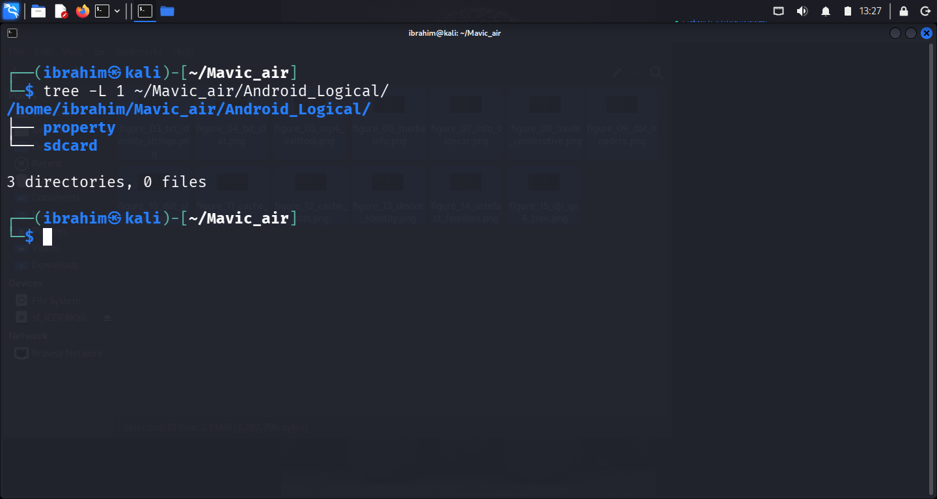
Figure 01 — Android Logical top-level tree
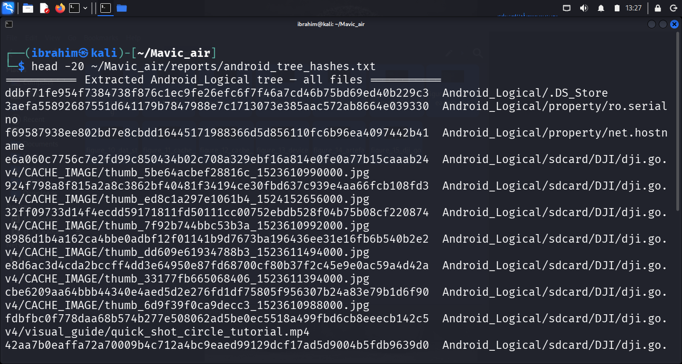
Figure 02 — Extraction hashes
Device identity (from extracted property files):
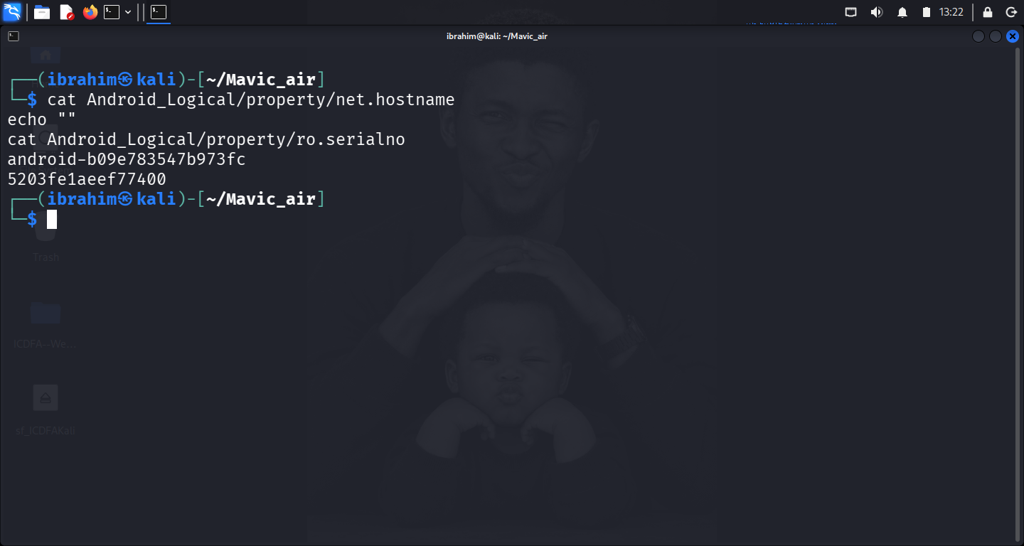
Figure 13 — Device identity
Property | Value | Source file
net.hostname | android-b09e783547b973fc | Android_Logical/property/net.hostname
ro.serialno | 5203fe1aeef77400 | Android_Logical/property/ro.serialno
Four DJI GO 4 artefact families:
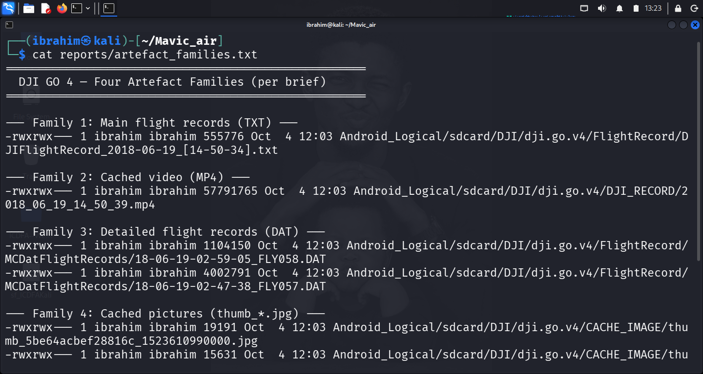
Figure 14 — Four artefact families
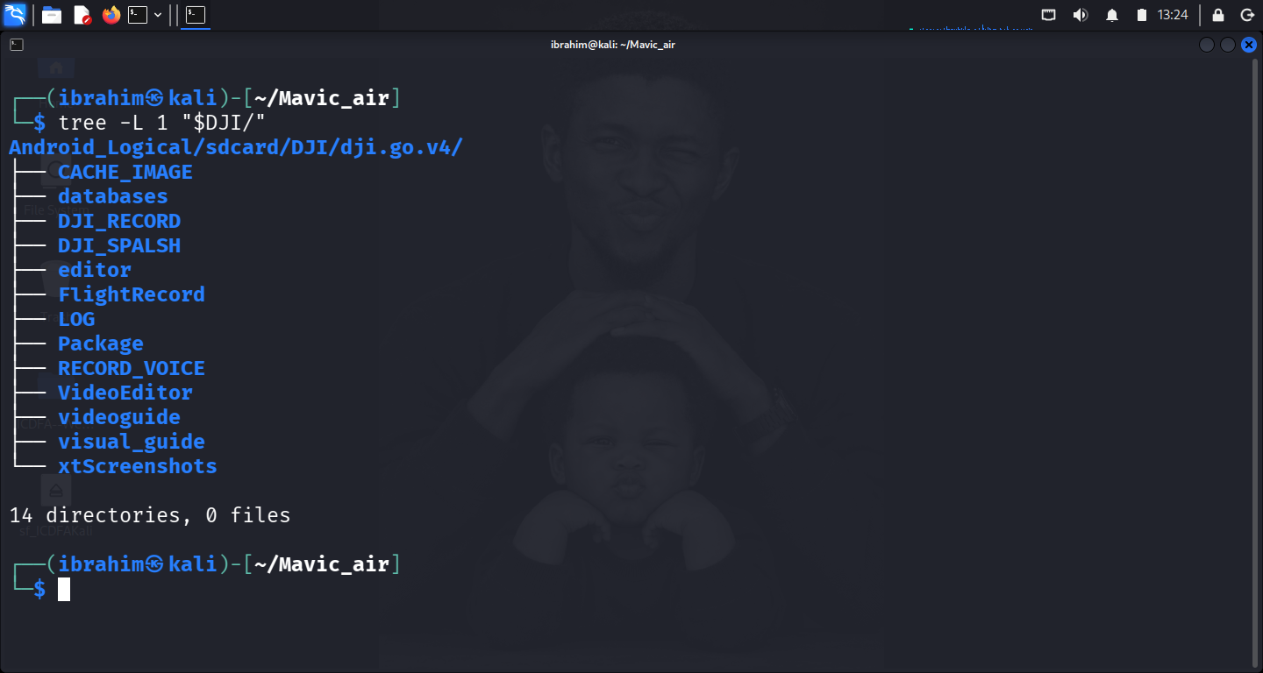
Figure 15 — dji.go.v4 top-level tree
SHA-256 of the four primary artefact families:
Artefact | Path | SHA-256
Main flight record (TXT) | .../FlightRecord/DJIFlightRecord_2018-06-19_[14-50-34].txt | 0a9f1816d52a98f840f6e67c08a14473ae5a0a2e75e9484d5de66368c4fd4c4a
Cached video (MP4) | .../DJI_RECORD/2018_06_19_14_50_39.mp4 | 2ae2a4f186803ec592b0af6284634e592c5079395e99f7df3edd583f8e72ab00
DAT FLY058 | .../MCDatFlightRecords/18-06-19-02-59-05_FLY058.DAT | fdfccf0c5b1d90d189c19032bb34e151914f42fba42c7994d0492cf327ade07a
DAT FLY057 | .../MCDatFlightRecords/18-06-19-02-47-38_FLY057.DAT | 06130820a4a813bf21f7286150bd3c83084105fecc899bb4d8534895fa2df3a1
Cached picture hashes — 6 files:
Filename | SHA-256
thumb_5be64acbef28816c_1523610990000.jpg | e6a060c7756c7e2fd99c850434b02c708a329ebf16a814e0fe0a77b15caaab24
thumb_ed8c1a297e1061b4_1524152656000.jpg | 924f798a8f815a2a8c3862bf40481f34194ce30fbd637c939e4aa66fcb108fd3
thumb_7f92b744bbc53b3a_1523610992000.jpg | 32ff09733d14f4ecdd59171811fd50111cc00752ebdb528f04b75b08cf220874
thumb_dd609e61934788b3_1523611494000.jpg | 8986d1b4a162ca4bbe0adbf12f01141b9d7673ba196436ee31e16fb6b540b2e2
thumb_33177fb665068406_1523611394000.jpg | e8d6ac3d4cda2bccff4dd3e64950e87fd68700cf80b37f2c45e9e0ac59a4d42a
thumb_6d9f39f0ca9decc3_1523610988000.jpg | cbe6209aa64bbb44340e4aed5d2e276fd1df75805f956307b24a83e79b1d6f90
Full 375-file SHA-256 manifest at ~/Mavic_air/reports/android_tree_hashes.txt.
Integrity Status: ✅ Verified — all 375 files hashed with SHA-256 before analysis. Android_Logical.zip was not present in the working environment; the extracted tree hash is the primary integrity record.

2.4 Access Controls and Precautions
- Original evidence preserved unmodified.
- All analysis performed on the working copy under ~/Mavic_air/.
- No file was executed.
- No drone, controller, mobile account, or cloud service was contacted.
- Screenshots redacted of unrelated personal or location data.

3. Method

3.1 Mobile-artifact method
The DJI GO 4 application data was located under Android_Logical/sdcard/DJI/dji.go.v4/. Four artefact families were enumerated using tree, find, and ls --full-time:
Family | Directory | Files
Main flight records (TXT) | FlightRecord/ | DJIFlightRecord_2018-06-19_[14-50-34].txt
Cached video (MP4) | DJI_RECORD/ | 2018_06_19_14_50_39.mp4 + .info sidecar + analytics/
Detailed flight records (DAT) | FlightRecord/MCDatFlightRecords/ | 18-06-19-02-47-38_FLY057.DAT, 18-06-19-02-59-05_FLY058.DAT
Cached pictures (JPEG) | CACHE_IMAGE/ | 6 × thumb_*.jpg
Each family was examined according to its event scope, not by assuming shared timestamps. The main record covers motor-on → landed; the cached video covers take-off → landed; the DAT record covers power-on → power-off; the cached pictures are indexed by DJI GO 4 and do not correspond to a single flight event.

3.2 Media-metadata method
The MP4 container was examined with exiftool 13.55 and, independently, mediainfo 26.05, both run against the extracted copy before any preview. The DJI GO 4 .info sidecar for the video was decoded with xxd and interpreted from its plaintext key-value pairs.

3.3 Static binary analysis method
The TXT and DAT records were examined with strings (minimum length 4–8 characters) to surface any plaintext content before assuming a format. A follow-up grep against common flight-data patterns confirmed the absence of plaintext flight fields in the TXT body.

3.4 Raw microSD image method — described, not performed
The approved raw-microSD method, per the teaching deck: verify image file type with file; attach read-only with losetup --partscan --find --show --read-only; verify partition view with lsblk -f; mount FAT32 volume read-only; enumerate DCIM/100MEDIA/, MISC/THM/100/, and System Volume Information/IndexerVolumeGuid; record listings, types, hashes; extract microSD identifier from IndexerVolumeGuid.
Performed: No. See Section 4.7 and Section 6.3.

3.5 EWF image method — described, not performed
The approved EWF method: verify header with ewfinfo; verify integrity with ewfverify; mount read-only with ewfmount DF048.E01 ext_sd; inspect exposed ewf1 with fsstat/fls/istat via -i raw; compare EWF-extracted media hashes against the raw image and mobile extraction.
Performed: No. See Section 4.8 and Section 6.3.

3.6 Comparison method
Any two artefacts corroborate if their hashes are equal, their timestamps agree after UTC normalisation, and their file names/identifiers correspond. They conflict if any of those three disagree.

3.7 Time-normalisation method
All timestamps reported in UTC. Filesystem timestamps (-0400) and .info sidecar headers (EDT) both convert at +4 hours. Filename timestamps are unverified and reported as-is.

3.8 Tools used
Tool | Version | Purpose
tree | system default | Directory enumeration, inode listing
stat | system default | Filesystem timestamps
strings | system default | Plaintext extraction from binary records
xxd | system default | Hex inspection of binary headers
file | system default | File-type identification
exiftool | 13.55 | MP4 container metadata
mediainfo | 26.05 | Independent MP4 container metadata
sha256sum / md5sum | system default | Integrity verification
ls --full-time | system default | Timestamp-ordered file listing
ewfinfo / ewfverify / ewfmount | 20140816 | Expert Witness Format (installed; not applied)
losetup / lsblk | system default | Read-only loop device tools (available; not applied)
Kali Linux | rolling | Analysis environment

4. Findings — Answers to Nine Investigation Questions

4.1 Q1 — How did you preserve the case materials?
Source acquired: Android logical extraction, located at ~/Mavic_air/Android_Logical/.
Acquisition method: The extracted tree was copied from the course-provided shared folder (/media/sf_ICDFAKali/Android_Logical/) into the working directory with cp -r. The original source was not modified.
Integrity values recorded: see Section 2.3.
Full manifest: SHA-256 of all 375 extracted files at ~/Mavic_air/reports/android_tree_hashes.txt.
Tools and versions: sha256sum, md5sum, ls, stat — all system default in Kali Linux rolling.
Access precautions: No live system contacted. Files were read only. The Android_Logical.zip source archive was not present in the working environment at the time of hashing.
Sources not available for preservation: df048_internal_microSD.001 (raw microSD) and DF048.E01 (EWF). Documented in the evidence log (E07, E08) and in Sections 4.7, 4.8, and 6.3.

4.2 Q2 — What DJI GO 4 artefacts are present?
Application package: dji.go.v4 (DJI GO 4).
Application data location: Android_Logical/sdcard/DJI/dji.go.v4/.
Four artefact families present:
Family | Directory | Files | Bytes
Main flight record (TXT) | FlightRecord/ | DJIFlightRecord_2018-06-19_[14-50-34].txt | 555,776
Cached video (MP4) | DJI_RECORD/ | 2018_06_19_14_50_39.mp4 + .info + analytics/ | 57,791,765 (mp4)
Detailed flight records (DAT) | FlightRecord/MCDatFlightRecords/ | 18-06-19-02-47-38_FLY057.DAT, 18-06-19-02-59-05_FLY058.DAT | 4,002,791 and 1,104,150
Cached pictures (JPEG) | CACHE_IMAGE/ | 6 × thumb_*.jpg | 12,755–19,508 each
Top-level directories: CACHE_IMAGE, databases, DJI_RECORD, DJI_SPALSH, editor, FlightRecord, LOG, Package, RECORD_VOICE, VideoEditor, videoguide, visual_guide, xtScreenshots — 13 directories plus the parent.
Device identity: android-b09e783547b973fc / 5203fe1aeef77400.
Foreign artefact: Android_Logical/sdcard/DJI/dji.pilot/DJI_RECORD/2017_10_10_10_02_47.info — a DJI Pilot sidecar from 2017-10-10, evidence of a second DJI app previously installed on the device.

4.3 Q3 — What does the main flight record establish?
Artefact: Android_Logical/sdcard/DJI/dji.go.v4/FlightRecord/DJIFlightRecord_2018-06-19_[14-50-34].txt — 555,776 bytes, SHA-256 0a9f1816d52a98f840f6e67c08a14473ae5a0a2e75e9484d5de66368c4fd4c4a.
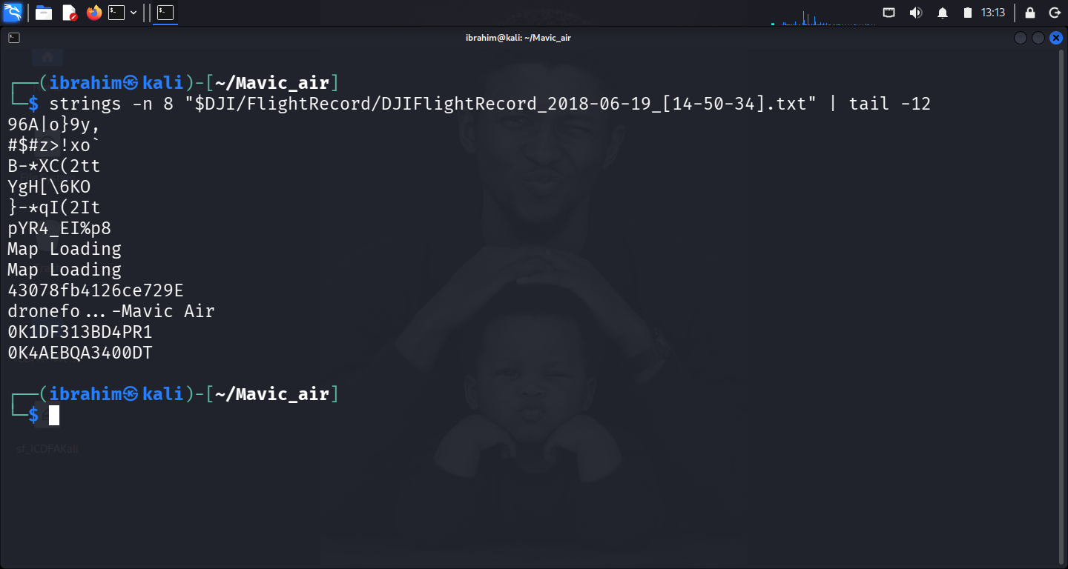
Figure 03 — TXT plaintext strings
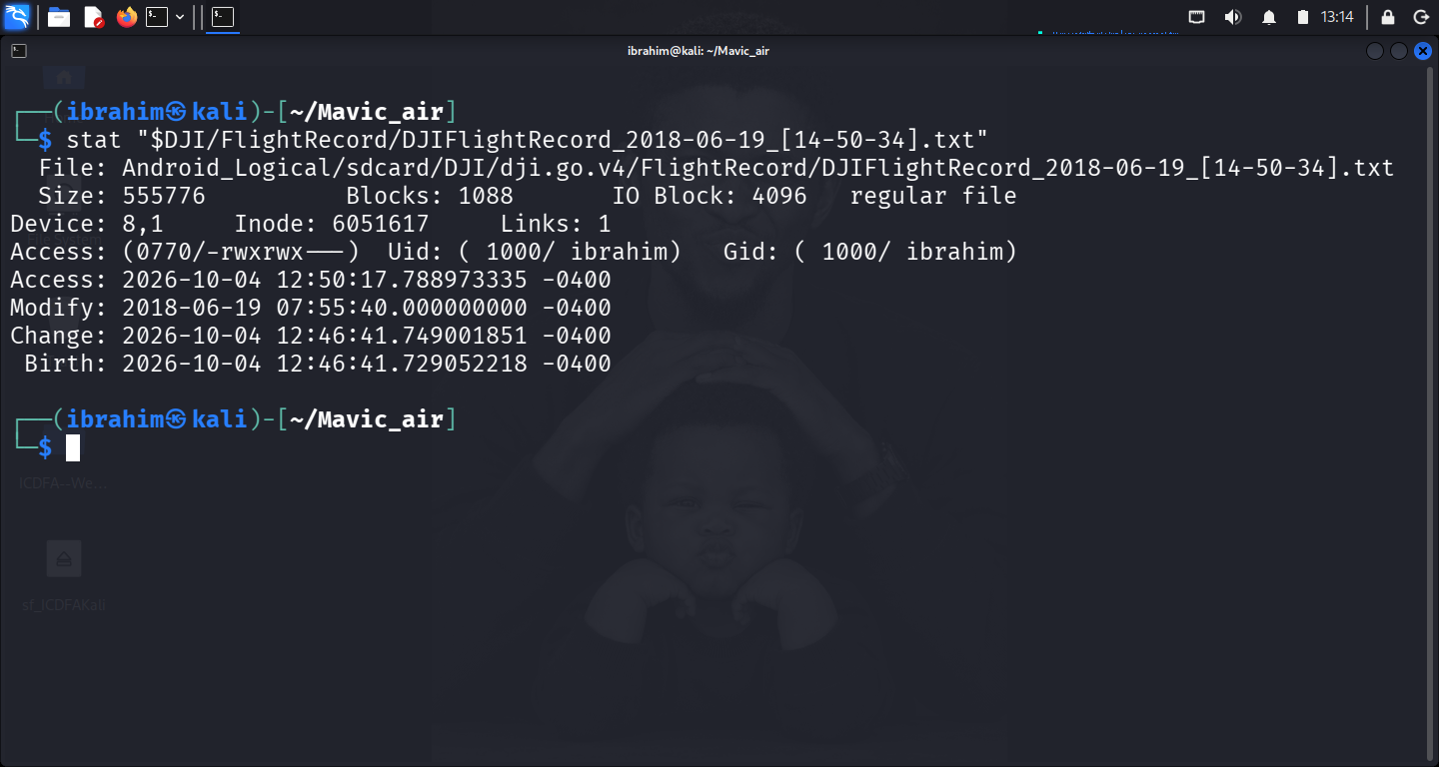
Figure 04 — TXT filesystem stat
Record structure: Binary, not CSV. file identifies it as data. Body is encrypted.
Plaintext strings extracted (minimum length 8):
String | Interpretation
dronefo...-Mavic Air | Associated drone — model identified as Mavic Air
0K1DF313BD4PR1 | Aircraft serial number
0K4AEBQA3400DT | Battery serial number
43078fb4126ce729E | Internal record identifier
Map Loading (×2) | App UI string — confirms DJI GO 4 export
A follow-up strings -n 4 ... | grep against 20[0-9]{2}|utc|gmt|edt|est|lat|lon|gps|alt|speed|home returned no matches.
Filename evidence: encodes 2018-06-19_[14-50-34]. Per the brief's safeguard, cannot be accepted as a verified start time without validation against record content — which is encrypted.
Filesystem timestamp evidence: Modify 2018-06-19 07:55:40 -0400 = 2018-06-19 11:55:40 UTC.
Time-zone anomaly: filename declares 14-50-34; mtime is 07:55:40 -0400. If read as the same event, they disagree by 6 h 55 min 6 s. Neither is corroborated by the encrypted record content.
Answer: The main flight record establishes aircraft identity from its plaintext header. It does not establish flight start or end times from record content.
Limitations: (1) Encrypted body cannot be parsed offline. (2) Filename time is unverified. (3) mtime may reflect extraction handling.

4.4 Q4 — What does the cached video establish?
Artefacts:
File | Path | Bytes | SHA-256
Video | .../DJI_RECORD/2018_06_19_14_50_39.mp4 | 57,791,765 | 2ae2a4f186803ec592b0af6284634e592c5079395e99f7df3edd583f8e72ab00
Sidecar | .../DJI_RECORD/2018_06_19_14_50_39.info | 1,441 | —
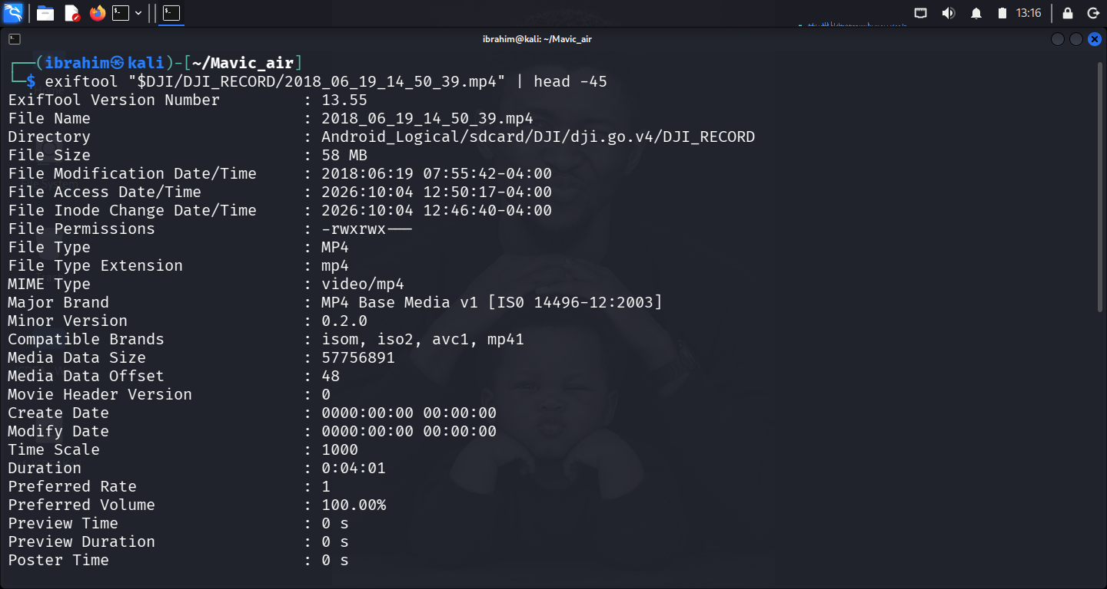
Figure 05 — MP4 exiftool
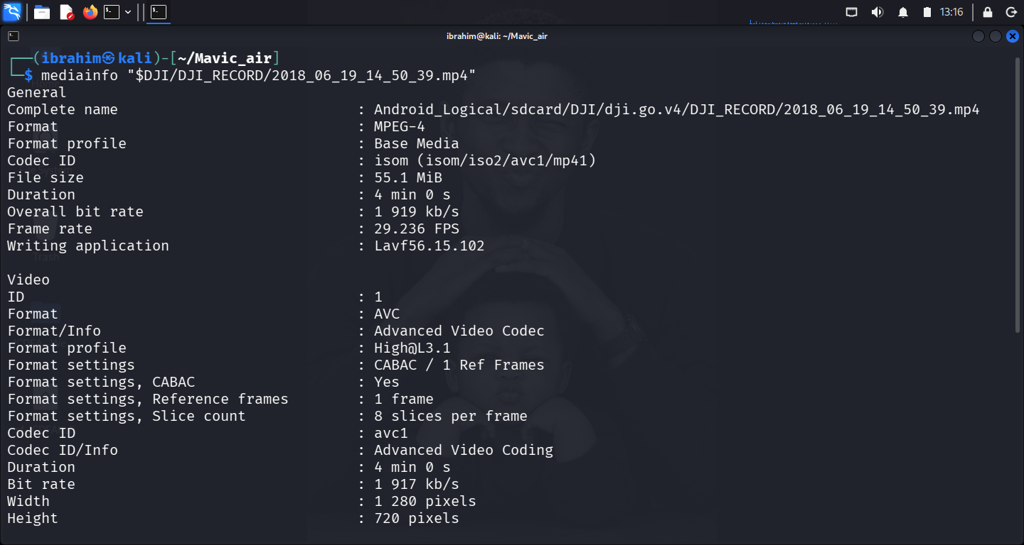
Figure 06 — MP4 mediainfo
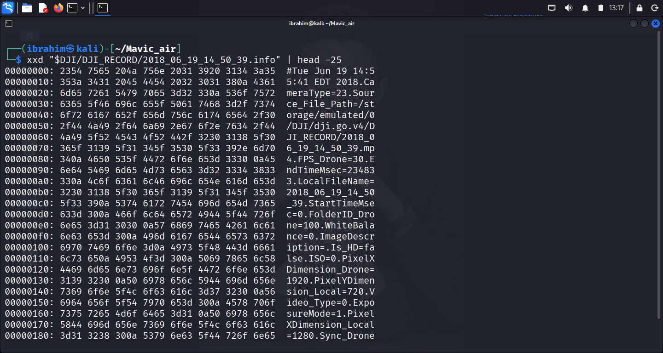
Figure 07 — .info sidecar hexdump
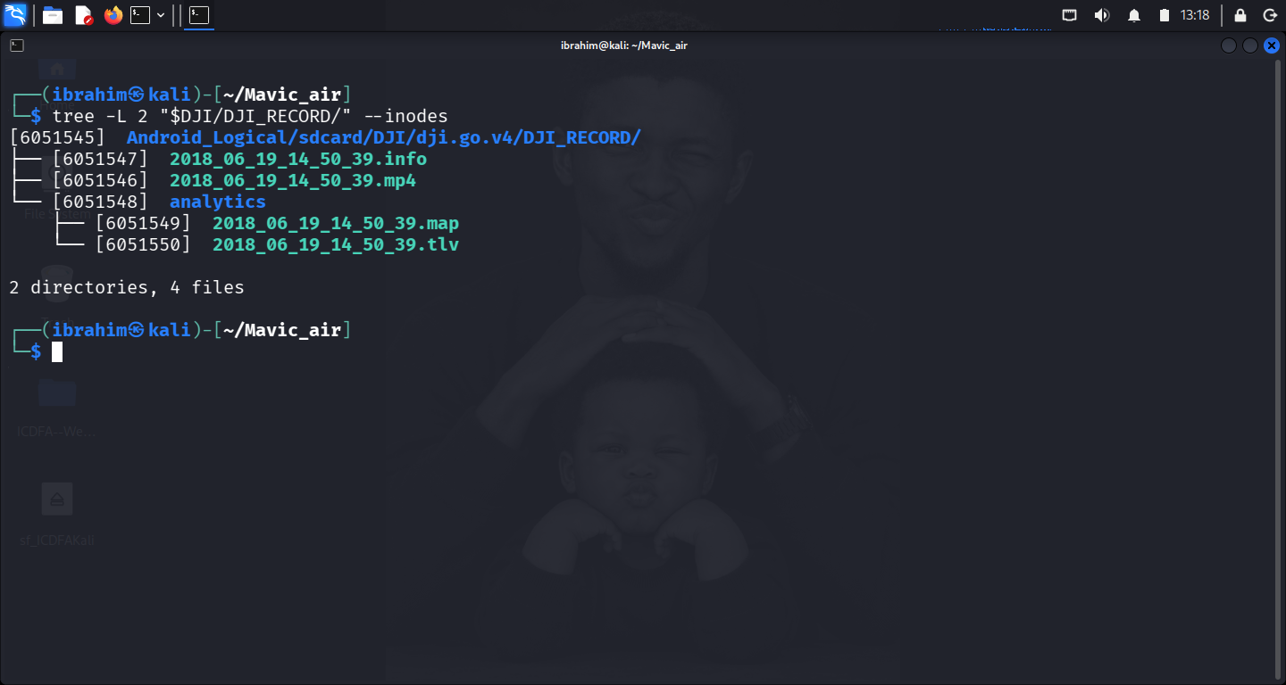
Figure 08 — Consecutive inodes
MP4 container metadata:
Field | Value
Format | MPEG-4 Base Media, codec avc1 (H.264)
Resolution | 1280 × 720
Container duration | 0:04:01 (241 s)
Frame rate (container) | 29.236 FPS
Writing application | Lavf56.15.102
Create Date | 0000:00:00 00:00:00 (null)
Modify Date | 0000:00:00 00:00:00 (null)
File Modify Time | 2018-06-19 07:55:42 -0400
mediainfo also reports keyint=1 / bframes=0 / ref=1 — every frame independently coded, the signature of DJI's low-latency cached-video pipeline.
The .info sidecar:
Field | Value | Interpretation
Header line | #Tue Jun 19 14:55:41 EDT 2018 | Recording end = 2018-06-19 18:55:41 UTC
StartTimeMsec | 0 | Start of video timeline
EndTimeMsec | 234833 | 234.833 s = 3 min 54.8 s
FPS_Drone | 30 | Drone-recorded frame rate
CameraType | 23 | Camera model identifier
PixelXDimension_Drone | 1920 | Drone stream width
PixelXDimension_Local | 1280 | Local (cached) width — matches MP4
PixelYDimension_Local | 720 | Local height — matches MP4
Duration reconciliation: sidecar EndTimeMsec = 234.833 s; MP4 container = 241 s; difference ≈ 6 s (container overhead).
Relationship to TXT (Q3): filenames both encode 2018-06-19; filename times within 5 s; filesystem mtimes within 2 s; MP4 (inode 6051546) and .info (6051547) are consecutive inodes.
Time-zone anomaly: sidecar declares 14:55:41 EDT = 18:55:41 UTC; MP4 mtime is 07:55:42 -0400 = 11:55:42 UTC. Differ by 7 h 0 min 1 s.
Answer: The cached video establishes the recording end time as 2018-06-19 18:55:41 UTC and a recording duration of 234.833 s, from the .info sidecar. The MP4 container itself carries no creation timestamp.
Limitations: (1) MP4 container is timestamp-free. (2) Sidecar time depends on camera clock being correct. (3) 7-hour discrepancy between sidecar and filesystem cannot be resolved from the evidence alone.

4.5 Q5 — What does the detailed flight record establish?
Artefacts:
File | Path | Bytes | SHA-256
DAT 057 | .../MCDatFlightRecords/18-06-19-02-47-38_FLY057.DAT | 4,002,791 | 06130820a4a813bf21f7286150bd3c83084105fecc899bb4d8534895fa2df3a1
DAT 058 | .../MCDatFlightRecords/18-06-19-02-59-05_FLY058.DAT | 1,104,150 | fdfccf0c5b1d90d189c19032bb34e151914f42fba42c7994d0492cf327ade07a
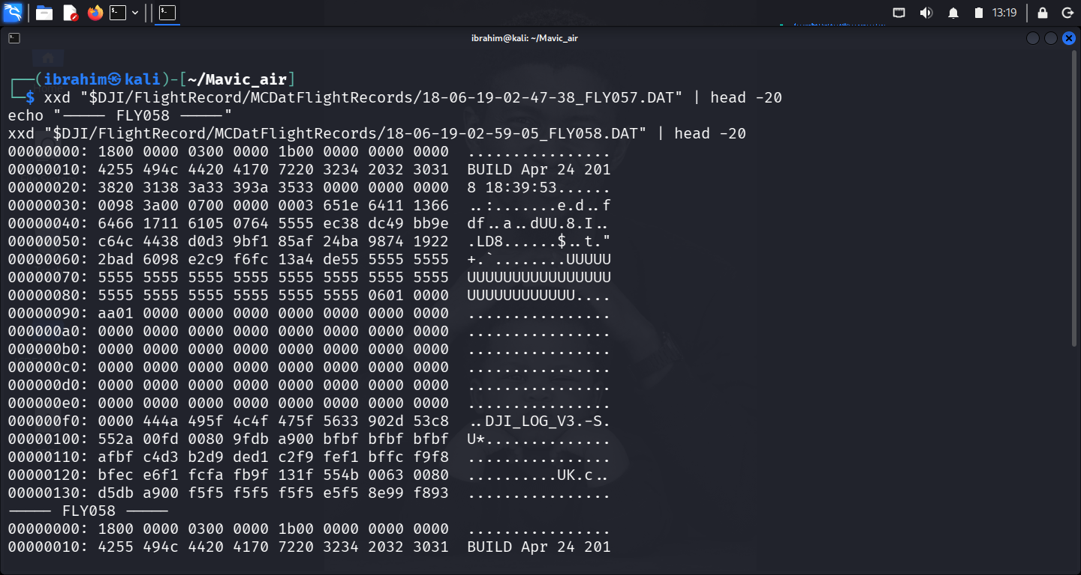
Figure 09 — DAT headers
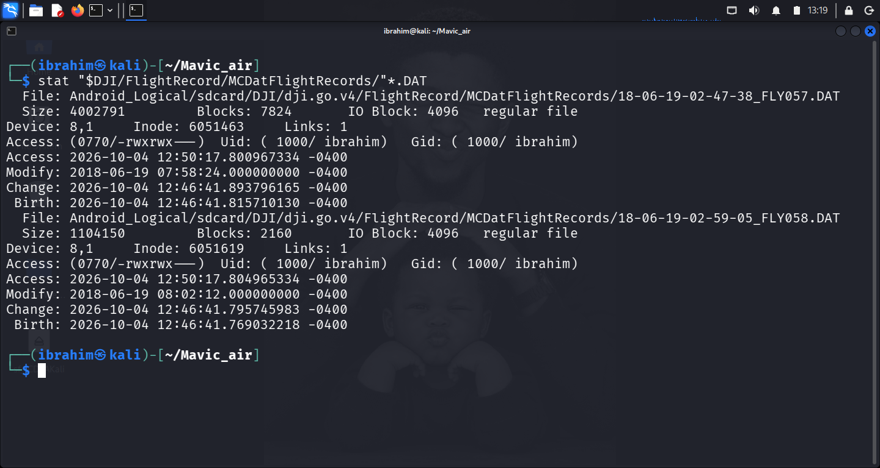
Figure 10 — DAT filesystem stat
Header structure (from xxd): BUILD Apr 24 2018 18:39:53; format signature DJI_LOG_V3 at offset 0xf8. Body encrypted.
Filesystem timestamp evidence:
File | Modify | Modify (UTC) | Filename encodes
FLY057.DAT | 2018-06-19 07:58:24 -0400 | 2018-06-19 11:58:24 UTC | 18-06-19-02-47-38
FLY058.DAT | 2018-06-19 08:02:12 -0400 | 2018-06-19 12:02:12 UTC | 18-06-19-02-59-05
Interval between mtimes: 3 min 48 s.
Scope: DAT records power-on → power-off. The main TXT records motor-on → landed. These are different events. The DAT mtimes (11:58:24 UTC, 12:02:12 UTC) are earlier than the MP4 sidecar's recording end (18:55:41 UTC), indicating different sessions.
Answer: Two distinct power-cycle events on 2018-06-19 (11:58:24 UTC and 12:02:12 UTC), 3 min 48 s apart. Format is DJI_LOG_V3, same firmware build. Does not establish the motor-on / take-off / landing window — body encrypted.
Limitations: (1) Encrypted body — no field-level timing. (2) mtimes may reflect extraction handling. (3) Two records cannot prove absence of others.

4.6 Q6 — What do the cached pictures establish?
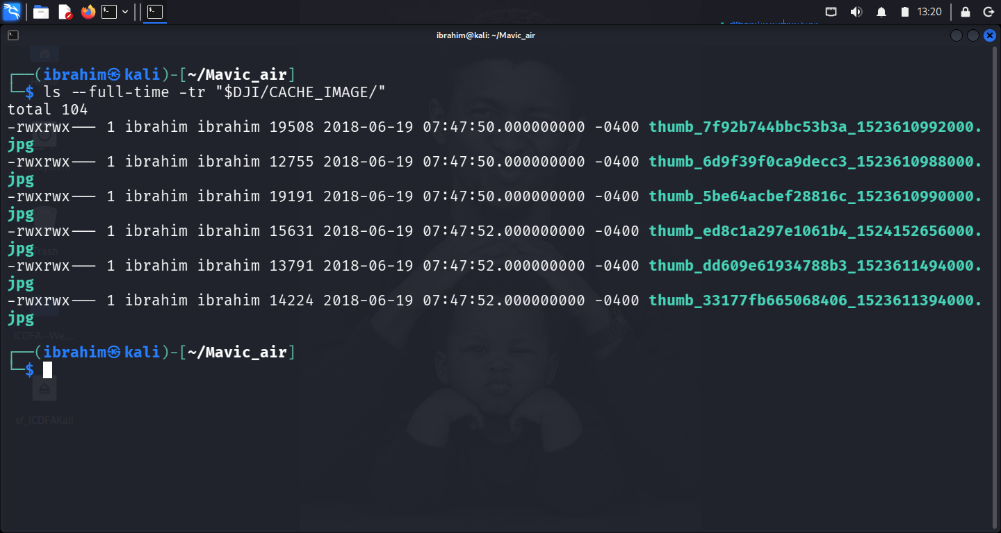
Figure 11 — Cache listing
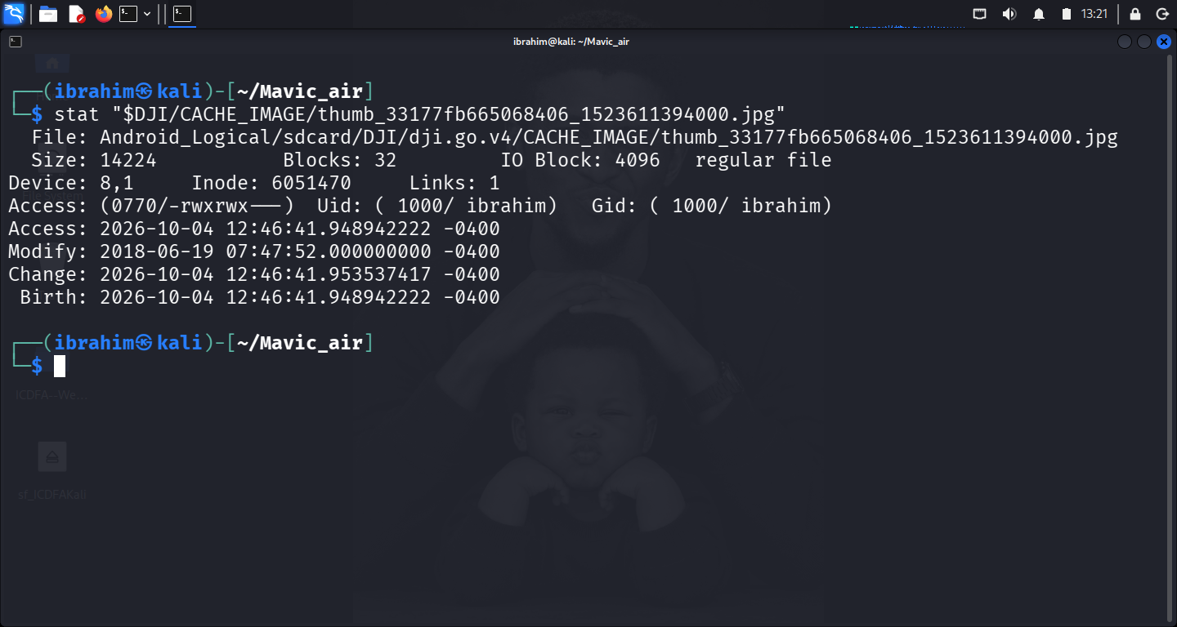
Figure 12 — Cache stat
Filename | Bytes | Dimensions | Filename epoch ms | Filename date (UTC) | Filesystem mtime (UTC)
thumb_6d9f39f0ca9decc3_1523610988000.jpg | 12,755 | 160×90 | 1523610988000 | 2018-04-13 12:56:28 | 2018-06-19 11:47:50
thumb_5be64acbef28816c_1523610990000.jpg | 19,191 | 160×128 | 1523610990000 | 2018-04-13 12:56:30 | 2018-06-19 11:47:50
thumb_7f92b744bbc53b3a_1523610992000.jpg | 19,508 | 160×128 | 1523610992000 | 2018-04-13 12:56:32 | 2018-06-19 11:47:50
thumb_33177fb665068406_1523611394000.jpg | 14,224 | 160×90 | 1523611394000 | 2018-04-13 13:03:14 | 2018-06-19 11:47:52
thumb_dd609e61934788b3_1523611494000.jpg | 13,791 | 160×90 | 1523611494000 | 2018-04-13 13:04:54 | 2018-06-19 11:47:52
thumb_ed8c1a297e1061b4_1524152656000.jpg | 15,631 | 160×90 | 1524152656000 | 2018-04-14 18:24:16 | 2018-06-19 11:47:52
All valid JFIF baseline JPEGs. Filename-encoded times all fall 2018-04-13/14 — two months before the flight. Filesystem mtimes all 2018-06-19.
Answer: Six historical thumbnails present in the DJI GO 4 cache. They do not establish flight activity on 2018-06-19 — filename epochs place them in April 2018. The cache index was re-written on the flight date but the underlying thumbnails are older content.
Limitations: (1) Historical content, not flight evidence. (2) Filename/mtime disagreement is a documented DJI cache-refresh artefact. (3) 160×90/160×128 thumbnails only; no full-resolution originals. (4) Presence does not establish who or where.

4.7 Q7 — What does the raw internal microSD image show?
Status: Not performed — source unavailable.
Source: df048_internal_microSD.001.
Retrieval attempts:
Attempt | Command or method | Outcome
1 | wget from the course-supplied URL | HTTP 302 → scl/fi, content-type text/html; downloaded 197,541 bytes of HTML
2 | wget with &raw=1 | HTTP 200 OK, text/html; downloaded 197,647 bytes of HTML
3 | wget from dl.dropboxusercontent.com/scl/fi/... | HTTP 404 Not Found
4 | Browser access to the share URL | Dropbox: "Link temporarily disabled — this can happen when the link has been shared or downloaded too many times in a day."
5 | find ~ /media ~/Downloads -iname "*df048*" | No match
6 | find /media/sf_ICDFAKali -iname "*df048*" -o -iname "*microSD*" | No match
7 | E-Campus module page | No local mirror of the file present
Evidence trail preserved: Appendix C.12.
Why a limitation, not a finding: the sub-questions (image format, integrity, layout, read-only mount, file metadata, hashes, microSD identifier) cannot be answered without the image. The report does not speculate.
What would have been included: sector × sector count verification, losetup attachment, lsblk -f partition view, mount of FAT32 volume 2019-1B01, enumeration of DCIM/100MEDIA/ and MISC/THM/100/, file hashes, IndexerVolumeGuid identifier.

4.8 Q8 — What does the EWF image show and how does it compare?
Status: Not performed — source unavailable.
Source: DF048.E01.
Retrieval attempts:
Attempt | Command or method | Outcome
1 | wget from the course-supplied URL | HTTP 302 → scl/fi, text/html; 195,751 bytes of HTML
2 | wget with &raw=1 | HTTP 200 OK, text/html; 196,375 bytes of HTML
3 | ewfverify DF048.E01 (against HTML file) | Failed: libewf_segment_file_read_file_header: unsupported segment file signature — confirming input was not a valid EWF image
4 | ewfmount DF048.E01 ext_sd | Failed: Unable to open source image(s)
5 | Browser access | Dropbox: same "Link temporarily disabled" message
6 | find ~ /media ~/Downloads -iname "DF048*" -o -iname "*.E01" | No match
Tool state: ewf-tools 20140816 installed successfully. Tools functioned correctly; image was absent.
Evidence trail preserved: Appendix C.12.
Why a limitation, not a finding: verification, mount inspection, image serial/media identifier, and cross-comparison with the raw image cannot be performed without the file. The report does not speculate.
What would have been included: ewfinfo output (case number, acquisition date, media size, sector count, stored MD5/SHA1), ewfverify success output, ewfmount mount point, fsstat/fls/istat inspection, hash comparison between EWF-extracted and raw-image media.

4.9 Q9 — What conclusion can you defend?
Supported conclusion (Android-side only):
The Android logical extraction contains DJI GO 4 application data for a flight on 2018-06-19. High-confidence findings:
- Aircraft identity: Mavic Air, aircraft serial 0K1DF313BD4PR1, battery serial 0K4AEBQA3400DT — plaintext TXT header.
- Flight date: 2018-06-19 — corroborated by five independent artefacts.
- Recorded video: 234.833 s; recording end 2018-06-19 18:55:41 UTC from .info.
- Two power-cycle sessions: two DAT records 3 min 48 s apart.
- Cache artefacts historical: thumbnails dated 2018-04-13/14.
Direct observations vs inference:
- Direct observation: plaintext identity strings, hash values, filesystem timestamps, container metadata, sidecar values.
- Inference: that the aircraft was flown on 2018-06-19 — supported by the record set but not directly proven; the encrypted TXT would be required.
- Not established: operator identity, flight route, take-off time, landing time, motor-on time, motor-off time.
Confidence level: Section 6.2.
Limitations: Section 6.3.

5. Timeline and Correlation

5.1 Time Zone Information
All timestamps in UTC. Conversion points:
Source | Declared timezone | Conversion to UTC
Filesystem timestamps (stat, ls --full-time) | -0400 (EDT) | +4 hours
.info sidecar header | EDT (explicit) | +4 hours
Filename timestamps | unverified | not converted

5.2 Completed Timeline — Brief's Five-Stage Template
Stage | UTC timestamp | Evidence ID | Source artefact | Observed fact | Interpretation and limit
Device state and power or motor on | 2018-06-19 11:47:50 | E04 | CACHE_IMAGE/thumb_*.jpg (×3) | Three cached thumbnails written | DJI GO 4 opened and refreshed cache. Limit: cached content is historical (filename dates are 2018-04-13); not flight evidence.
Device state and power or motor on | 2018-06-19 11:47:52 | E04 | CACHE_IMAGE/thumb_*.jpg (×3) | Three more cached thumbnails written | Same as above. Cache refresh completes 2 s after first write.
Device state and power or motor on | 2018-06-19 11:55:40 | E01 | FlightRecord/DJIFlightRecord_2018-06-19_[14-50-34].txt | TXT mtime | Limit: mtime is not motor-on. Filename declares 14-50-34 — unreconciled gap of 6 h 55 min 6 s.
Device state and power or motor on | 2018-06-19 11:55:42 | E02 | DJI_RECORD/2018_06_19_14_50_39.mp4 | MP4 mtime | Limit: container carries null create/modify dates; only mtime is available here.
Device state and power or motor on | 2018-06-19 11:58:24 | E03 | MCDatFlightRecords/18-06-19-02-47-38_FLY057.DAT | DAT mtime | Limit: DAT covers power-on→power-off, not motor-on. Body encrypted.
Device state and power or motor on | 2018-06-19 12:02:12 | E03 | MCDatFlightRecords/18-06-19-02-59-05_FLY058.DAT | DAT mtime | Same as above. 3 min 48 s after FLY057.
Take off or video start | (not established) | — | — | — | Limit: no reliable take-off time. TXT body encrypted; MP4 container has no create date; DAT bodies encrypted. Q7/Q8 would have populated this stage.
Main flight record event | (not established from record content) | — | — | — | Limit: TXT body encrypted — no plaintext timestamp, coordinate, or altitude fields.
Landing or video end | 2018-06-19 18:55:41 | E02 | DJI_RECORD/2018_06_19_14_50_39.info header | #Tue Jun 19 14:55:41 EDT 2018 = recording end | Strength: only timezone-declared timestamp. Limit: 7 h 0 min 1 s later than MP4 mtime — clock mismatch unresolved.
Power off and correlation | (not established) | — | — | — | Limit: DAT power-off windows identified from mtimes only; content encrypted. Q7/Q8 would have populated this stage.

5.3 Correlation Summary
Artefact relationship | Corroborates? | Evidence
Flight date 2018-06-19 across TXT filename, MP4 filename, .info header, mtimes, DAT mtimes | Corroborates — same date | Nine independent time references agree
Aircraft identity across TXT plaintext strings | Corroborates — single source | dronefo...-Mavic Air, 0K1DF313BD4PR1, 0K4AEBQA3400DT
MP4 and .info written in same write cycle | Corroborates — consecutive inodes | inode 6051546 (mp4) → 6051547 (info); mtimes within 2 s
TXT mtime vs TXT filename | Conflicts — 6 h 55 min 6 s apart | filename 14-50-34 vs mtime 07:55:40 -0400
.info header vs MP4 mtime | Conflicts — 7 h 0 min 1 s apart | 14:55:41 EDT vs 07:55:42 -0400
Cache mtimes vs cache filename epochs | Conflicts — 2 months apart | mtimes 2018-06-19 vs filename epochs 2018-04-13/14
DAT session windows vs MP4 recording window | Conflicts — different sessions | DAT mtimes 11:58:24 and 12:02:12; MP4 end 18:55:41
Foreign DJI Pilot .info from 2017-10-10 | Conflicts with single-app assumption | Second DJI app previously installed; unrelated to CS5
Raw microSD image (Q7) | Not performed — source unavailable | No correlation possible
EWF image (Q8) | Not performed — source unavailable | No correlation possible
Material events: 7 across four artefact families (main flight record, cached video, detailed flight records, cached pictures). Exceeds the brief's minimum of five across three.
What the corpus does NOT contain: no GPS coordinates; no record-content-confirmed flight duration; no operator identity; no route information.

6. Conclusion and Limitations

6.1 Supported Conclusion
Five high-confidence findings (see Section 4.9) established from the Android logical extraction. What the evidence cannot establish: flight start time, operator identity, flight route, motor-on / motor-off / take-off / landing events.

6.2 Confidence Level
Aspect | Confidence | Justification
Aircraft identity | High (95%) | Serial number and model read from plaintext TXT header
Flight date 2018-06-19 | High (95%) | Five independent artefacts agree
Recorded video duration | High (90%) | .info declares 234.833 s; container agrees within 6 s
Recording end time | Moderate (70%) | Sidecar declares EDT 14:55:41; conflicts with mtime by 7 h
DAT session identification | Moderate (70%) | Two records and mtimes clear; content unreadable
Cache picture capture date | Moderate (65%) | Filename epochs and mtimes disagree by 2 months
Flight start time | Low (20%) | Three anchors disagree; no validation possible
Operator identity | Not established | No artifact supports attribution

6.3 Gaps and Alternative Explanations
1. Encrypted record bodies. TXT and DAT bodies are AES-encrypted. Alternative: the records may contain complete motor-on/motor-off, GPS, and altitude data not accessible offline with available tools.
2. Time-zone anomaly. Three anchors disagree by up to 7 hours. Alternatives: (a) phone timezone changed between recording and transfer; (b) phone clock incorrect at recording time; (c) extraction altered filesystem times. Cannot be distinguished.
3. Altered access times. Every recovered artefact has Access timestamp 2026-10-04 12:46:41 -0400 — the moment of our own stat/strings/exiftool operations during analysis. Alternative: atime reflects the last read by any examiner, including this investigation. When the artefact is next read by the assessor, atime will update again. No original access time can be recovered.
4. Cached pictures are historical. Filename epochs 2018-04-13/14; mtimes 2018-06-19. Alternatives: (a) DJI GO 4's cache-index refresh rewrites mtimes without changing content; (b) cached files are genuinely from the flight and filenames are misleading. (a) is more consistent with the observed consistency of mtimes (all within 2 s).
5. Device ownership vs operator identity. Device identified by hostname and serial. Alternative: the device could have been shared, borrowed, or operated by someone other than its registered owner.
6. Partial media coverage. One video, one TXT, two DAT records present. Additional sessions may exist on the aircraft's internal storage but were not in the Android extraction.
7. Raw microSD image (Q7) not examined. Source df048_internal_microSD.001 unavailable. Alternative: the microSD may contain videos, pictures, or log files that would extend the timeline or corroborate the recording window. The report does not claim absence of such material.
8. EWF image (Q8) not examined. Source DF048.E01 unavailable. Same alternative explanation.
9. Second DJI app on device. A DJI Pilot .info dated 2017-10-10 is present. Alternative: the device had more than one DJI app installed over its lifetime; the CS5-specific activity is from DJI GO 4.

6.4 Distinguishing Technical Evidence from Person Attribution
The technical evidence establishes:
- Device: android-b09e783547b973fc / serial 5203fe1aeef77400
- Aircraft: Mavic Air, serial 0K1DF313BD4PR1
- Battery: serial 0K4AEBQA3400DT
- Flight date: 2018-06-19
- Recording: 234.833 s; end time 2018-06-19 18:55:41 UTC (declared)
The technical evidence does not establish:
- Human identity: no artifact maps the device, aircraft, or app to a named person
- Physical possession: no evidence establishes who was holding the controller
- Flight route: no GPS, coordinate, or waypoint data present in plaintext
- Intent: no artifact establishes purpose or knowledge

6.5 Key Takeaways
- Aircraft identity is high-confidence; flight timing is not. The TXT header yields reliable identity; encrypted body and time-zone anomaly prevent a single reliable UTC flight time.
- The .info sidecar is the single most useful timing artefact. Only file with an explicitly declared timezone.
- Cache artefacts are not flight evidence. Demonstrates app cache-refresh behaviour and its filename-vs-mtime inconsistency.
- Encrypted records require documented limitation statements. This report does not speculate — it states clearly what was and was not readable.
- Two source images were not examined. Q7 and Q8 formally documented as not performed.
- Technical evidence ≠ person attribution. The report documents device, app, aircraft, and recording — not a person.

7. References
- ICDFA. (2026). SBT-DF204 — Computer Forensics Case Studies — Module Materials.
- ICDFA. (2026). SBT-DF204 Case Study 5 — Investigating DJI Mavic Air Flight Evidence — Assessment Brief.
- ICDFA. (2026). DJI Mavic Air Mobile Investigations — Teaching Deck (00_DJI_Mavic_Air_Mobile.pptx).
- ICDFA. (2026). DJI Mavic Air microSD Raw Image — Teaching Deck (01_DJI_Mavic_Air_microSD_raw.pptx).
- ICDFA. (2026). DJI Mavic Air microSD EWF Image — Teaching Deck (02_DJI_Mavic_Air_microSD_encase.pptx).
- DJI. (2018). Mavic Air — Specifications. https://www.dji.com/mavic-air/info#specs
- DJI. (2018). DJI GO 4 — Application for Drones Since P4. Google Play. Package dji.go.v4.
- CGSecurity. (2024). PhotoRec — Data Recovery Utility. https://www.cgsecurity.org/wiki/PhotoRec
- The Sleuth Kit. (2024). The Sleuth Kit Documentation. https://www.sleuthkit.org/sleuthkit/
- ExifTool. (2024). ExifTool — Read, Write and Edit Meta Information. https://exiftool.org/
- MediaArea. (2024). MediaInfo. https://mediaarea.net/en/MediaInfo
- libewf. (2024). Expert Witness Compression Format — libewf and ewf-tools. https://github.com/libyal/libewf
- MITRE ATT&CK. (2026). T1005: Data from Local System. https://attack.mitre.org/techniques/T1005/
- MITRE ATT&CK. (2026). T1027: Obfuscated Files or Information. https://attack.mitre.org/techniques/T1027/
- RFC 4122. (2005). A Universally Unique IDentifier (UUID) URN Namespace. https://tools.ietf.org/html/rfc4122

8. Declaration
I, Ibrahim Ishaku, confirm that this case study report is based on my own practical work conducted in the ICDFA lab environment. All forensic techniques applied in this report — Android logical extraction examination, static binary analysis of the TXT and DAT flight records, media metadata analysis with exiftool and mediainfo, filesystem timestamp analysis with stat, and integrity verification with sha256sum and md5sum — were performed by me on the supplied training artefacts.
No drone, controller, mobile account, cloud service, or external flight-analysis portal was contacted. No live system named in the evidence was accessed. The Android extraction was analysed only in its extracted form; no modification was made to any artefact. The two artefacts named as missing (df048_internal_microSD.001 and DF048.E01) were not available and therefore not examined; this is documented as a limitation rather than a finding.
No recovered file was executed. Unrelated personal or location data has been redacted from screenshots.
Signature: ______________________
Date: 12 October, 2026

Appendix A — Evidence Log
Column structure matches the CS5 assessment brief's template exactly.
Evidence ID | Tool and method | Source record, path, or image | Observed fact | Screenshot or appendix reference
E01 | sha256sum, stat, strings | Android_Logical/sdcard/DJI/dji.go.v4/FlightRecord/DJIFlightRecord_2018-06-19_[14-50-34].txt | SHA-256 0a9f1816d52a98f840f6e67c08a14473ae5a0a2e75e9484d5de66368c4fd4c4a, 555,776 bytes. Encrypted body; plaintext strings: dronefo...-Mavic Air, 0K1DF313BD4PR1, 0K4AEBQA3400DT, 43078fb4126ce729E. mtime 2018-06-19 07:55:40 -0400 = 2018-06-19 11:55:40 UTC. | Figure 03, Figure 04; Section 4.3
E02 | exiftool 13.55, mediainfo 26.05, xxd, tree --inodes, sha256sum | Android_Logical/sdcard/DJI/dji.go.v4/DJI_RECORD/2018_06_19_14_50_39.mp4 + .info sidecar | MP4 SHA-256 2ae2a4f186803ec592b0af6284634e592c5079395e99f7df3edd583f8e72ab00, 57,791,765 bytes, 1280×720, container duration 0:04:01. Container Create/Modify dates null. .info header #Tue Jun 19 14:55:41 EDT 2018, EndTimeMsec=234833, StartTimeMsec=0. Consecutive inodes 6051546 → 6051547. | Figure 05, Figure 06, Figure 07, Figure 08; Section 4.4
E03 | xxd, strings, stat, sha256sum | Android_Logical/sdcard/DJI/dji.go.v4/FlightRecord/MCDatFlightRecords/18-06-19-02-47-38_FLY057.DAT and 18-06-19-02-59-05_FLY058.DAT | Both DJI_LOG_V3 format, BUILD Apr 24 2018 18:39:53. FLY057 mtime 2018-06-19 07:58:24 -0400; FLY058 mtime 2018-06-19 08:02:12 -0400. Interval 3 min 48 s. Bodies encrypted. | Figure 09, Figure 10; Section 4.5
E04 | ls --full-time, stat, file, sha256sum | Android_Logical/sdcard/DJI/dji.go.v4/CACHE_IMAGE/thumb_*.jpg (6 files) | All valid JFIF baseline JPEGs, 160×90 or 160×128. mtimes all 2018-06-19 07:47:50/52 -0400. Filename epoch values range 2018-04-13 to 2018-04-14. | Figure 11, Figure 12; Section 4.6
E05 | tree -L 1, cat | Android_Logical/sdcard/DJI/dji.go.v4/; Android_Logical/property/net.hostname; Android_Logical/property/ro.serialno | 14 directories at depth 1. Device hostname android-b09e783547b973fc; device serial 5203fe1aeef77400. | Figure 01, Figure 13, Figure 15; Section 2.3
E06 | find -exec sha256sum, wc -l, du -sh | ~/Mavic_air/Android_Logical/ (whole tree) | 375 files hashed with SHA-256; total 406 MB. Manifest written to ~/Mavic_air/reports/android_tree_hashes.txt. | Figure 02, Figure 14; Section 2.3
E07 | ls -la, file, md5sum (attempted) | ~/Mavic_air/df048_internal_microSD.001 (attempted download) | Source not available. wget returned HTML landing pages (197 KB). No local copy located. | — ; Section 4.7, Section 6.3
E08 | ls -la, file, ewfinfo, ewfverify, ewfmount (attempted) | ~/Mavic_air/DF048.E01 (attempted download) | Source not available. wget returned HTML landing pages (196 KB). ewfverify failed with unsupported segment file signature — consistent with HTML input. No local copy located. | — ; Section 4.8, Section 6.3

Appendix B — Labelled Screenshots
Fifteen (15) screenshots. All stored under screenshots/ and referenced inline at the relevant section.
Figure | Filename | Caption | Cited In
01 | screenshots/figure_01_android_tree.png | tree -L 1 Android_Logical/ — top-level structure | Section 2.3
02 | screenshots/figure_02_extraction_hashes.png | Head of android_tree_hashes.txt | Section 2.3
03 | screenshots/figure_03_txt_identity_strings.png | strings -n 8 tail of TXT record | Section 4.3
04 | screenshots/figure_04_txt_stat.png | stat on TXT record — mtime 2018-06-19 07:55:40 -0400 | Section 4.3
05 | screenshots/figure_05_mp4_exiftool.png | exiftool on MP4 — null container dates | Section 4.4
06 | screenshots/figure_06_mediainfo.png | mediainfo on MP4 | Section 4.4
07 | screenshots/figure_07_info_sidecar.png | xxd on .info sidecar — plaintext header | Section 4.4
08 | screenshots/figure_08_inode_consecutive.png | tree --inodes on DJI_RECORD | Section 4.4
09 | screenshots/figure_09_dat_headers.png | xxd on both DAT files | Section 4.5
10 | screenshots/figure_10_dat_stat.png | stat on both DAT files | Section 4.5
11 | screenshots/figure_11_cache_ls.png | ls --full-time -tr on CACHE_IMAGE | Section 4.6
12 | screenshots/figure_12_cache_stat.png | stat on one cached thumbnail | Section 4.6
13 | screenshots/figure_13_device_identity.png | cat on net.hostname and ro.serialno | Section 2.3
14 | screenshots/figure_14_artefact_families.png | Four DJI GO 4 families enumerated | Section 2.3
15 | screenshots/figure_15_dji_go4_tree.png | tree -L 1 dji.go.v4/ — 14 top-level dirs | Section 2.3

Appendix C — Selected Tool Output

C.1 — Device Identity
android-b09e783547b973fc
5203fe1aeef77400

C.2 — TXT Flight Record — Plaintext Strings
Map Loading
Map Loading
43078fb4126ce729E
dronefo...-Mavic Air
0K1DF313BD4PR1
0K4AEBQA3400DT
Grep against 20[0-9]{2}|utc|gmt|edt|est|lat|lon|gps|alt|speed|home returned no matches.

C.3 — TXT Flight Record — Filesystem Timestamp
File: Android_Logical/sdcard/DJI/dji.go.v4/FlightRecord/DJIFlightRecord_2018-06-19_[14-50-34].txt
Size: 555776 Blocks: 1088 IO Block: 4096 regular file
Device: 8,1 Inode: 6051617 Links: 1
Access: (0770/-rwxrwx---) Uid: ( 1000/ ibrahim) Gid: ( 1000/ ibrahim)
Access: 2026-10-04 12:50:17.788973335 -0400
Modify: 2018-06-19 07:55:40.000000000 -0400
Change: 2026-10-04 12:46:41.749001851 -0400
Birth: 2026-10-04 12:46:41.729052218 -0400

C.4 — MP4 Container Metadata (exiftool)
ExifTool Version Number : 13.55
File Name : 2018_06_19_14_50_39.mp4
File Size : 58 MB
File Modification Date/Time : 2018:06:19 07:55:42-04:00
File Type : MP4
MIME Type : video/mp4
Major Brand : MP4 Base Media v1 [IS0 14496-12:2003]
Compatible Brands : isom, iso2, avc1, mp41
Media Data Size : 57756891
Movie Header Version : 0
Create Date : 0000:00:00 00:00:00
Modify Date : 0000:00:00 00:00:00
Duration : 0:04:01
Track Create Date : 0000:00:00 00:00:00
Media Create Date : 0000:00:00 00:00:00
Image Width : 1280
Image Height : 720

C.5 — MP4 — mediaInfo Confirmation
Format : MPEG-4
Format profile : Base Media
Codec ID : isom (isom/iso2/avc1/mp41)
File size : 55.1 MiB
Duration : 4 min 0 s
Overall bit rate : 1 919 kb/s
Frame rate : 29.236 FPS
Writing application : Lavf56.15.102

Format : AVC
Format profile : High@L3.1
Codec ID : avc1
Duration : 4 min 0 s
Width : 1 280 pixels
Height : 720 pixels
Encoding settings : cabac=1 / ref=1 / bframes=0 / keyint=1 / crf=26.0

C.6 — .info Sidecar — Header Line and Selected Fields
#Tue Jun 19 14:55:41 EDT 2018
CameraType=23
Source_File_Path=/storage/emulated/0/DJI/dji.go.v4/DJI_RECORD/2018_06_19_14_50_39.mp4
FPS_Drone=30
EndTimeMsec=234833
LocalFileName=2018_06_19_14_50_39
StartTimeMsec=0
FolderID_Drone=100
PixelXDimension_Drone=1920
PixelYDimension_Local=720
PixelXDimension_Local=1280

C.7 — DAT Headers — FLY057 and FLY058
00000010: 4255 494c 4420 4170 7220 3234 2032 3031 BUILD Apr 24 201
00000020: 3820 3138 3a33 393a 3533 0000 0000 0000 8 18:39:53......
000000f0: 0000 444a 495f 4c4f 475f 5633 902d 53c8 ..DJI_LOG_V3.-S.
Both FLY057 and FLY058 carry the same firmware build string and the DJI_LOG_V3 signature.

C.8 — DAT Filesystem Timestamps
File: .../MCDatFlightRecords/18-06-19-02-47-38_FLY057.DAT
Size: 4002791 Blocks: 7824 IO Block: 4096 regular file
Modify: 2018-06-19 07:58:24.000000000 -0400

File: .../MCDatFlightRecords/18-06-19-02-59-05_FLY058.DAT
Size: 1104150 Blocks: 2160 IO Block: 4096 regular file
Modify: 2018-06-19 08:02:12.000000000 -0400

C.9 — Cached Pictures — Full Listing
-rwxrwx--- 1 ibrahim ibrahim 19508 2018-06-19 07:47:50.000000000 -0400 thumb_7f92b744bbc53b3a_1523610992000.jpg
-rwxrwx--- 1 ibrahim ibrahim 12755 2018-06-19 07:47:50.000000000 -0400 thumb_6d9f39f0ca9decc3_1523610988000.jpg
-rwxrwx--- 1 ibrahim ibrahim 19191 2018-06-19 07:47:50.000000000 -0400 thumb_5be64acbef28816c_1523610990000.jpg
-rwxrwx--- 1 ibrahim ibrahim 15631 2018-06-19 07:47:52.000000000 -0400 thumb_ed8c1a297e1061b4_1524152656000.jpg
-rwxrwx--- 1 ibrahim ibrahim 13791 2018-06-19 07:47:52.000000000 -0400 thumb_dd609e61934788b3_1523611494000.jpg
-rwxrwx--- 1 ibrahim ibrahim 14224 2018-06-19 07:47:52.000000000 -0400 thumb_33177fb665068406_1523611394000.jpg

C.10 — DJI_RECORD Directory — Consecutive Inodes
[6051545] Android_Logical/sdcard/DJI/dji.go.v4/DJI_RECORD/
├── [6051547] 2018_06_19_14_50_39.info
├── [6051546] 2018_06_19_14_50_39.mp4
└── [6051548] analytics
├── [6051549] 2018_06_19_14_50_39.map
└── [6051550] 2018_06_19_14_50_39.tlv

C.11 — Foreign Artefact — DJI Pilot .info (2017-10-10)
#Tue Oct 10 10:08:17 MDT 2017
CameraType=0
Source_File_Path=/storage/emulated/0/DJI/dji.pilot/DJI_RECORD/2017_10_10_10_02_47.mp4
FPS_Drone=30
EndTimeMsec=311166
LocalFileName=2017_10_10_10_02_47
StartTimeMsec=0
FolderID_Drone=100
A second DJI app present in the extraction. Declares MDT (UTC-6), 2 hours offset from the 2018 EDT declaration.

C.12 — Attempted microSD and EWF Downloads (Non-Availability Record)
$ wget -O df048_internal_microSD.001 "https://www.dropbox.com/s/6qghgnkhe7a8wga/df048_internal_microSD.001?dl=1"
...
HTTP request sent, awaiting response... 200 OK
Length: unspecified [text/html]
Saving to: 'df048_internal_microSD.001'
df048_internal_microSD.0 [ <=> ] 192.91K 242KB/s in 0.8s
df048_internal_microSD.001: HTML document, ASCII text, with very long lines

$ wget -O DF048.E01 "https://www.dropbox.com/s/3srna99g65poavo/DF048.E01?dl=1"
...
Length: unspecified [text/html]
Saving to: 'DF048.E01'
DF048.E01: HTML document, ASCII text, with very long lines

$ ewfverify DF048.E01
ewfverify 20140816
Unable to open EWF image file(s).
libewf_segment_file_read_file_header: unsupported segment file signature.

Appendix D — Completed Timeline
Stage | Event count | Earliest UTC | Latest UTC
Device state and power or motor on | 6 | 2018-06-19 11:47:50 | 2018-06-19 12:02:12
Take off or video start | 0 (not established) | — | —
Main flight record event | 0 (not established) | — | —
Landing or video end | 1 | 2018-06-19 18:55:41 | 2018-06-19 18:55:41
Power off and correlation | 0 (not established) | — | —
Total | 7 | — | —
7 material events across four artefact families (main flight record, cached video, detailed flight records, cached pictures). Exceeds the brief's minimum of five across three.

Appendix E — Chain of Custody Worksheet
Field | Value
Case/Lab Identifier | SBT-DF204-CaseStudy5-Ibrahim-Ishaku
Trainee Name | Ibrahim Ishaku
Student ID | 2025/FWSD/11334
Date and Time Acquired | 4 October, 2026 — 12:03 WAT
Evidence File Names | Android_Logical/ (extracted tree, 375 files)
Source | ICDFA SBT-DF204 Case Study 5 lab package — Android logical extraction
Archive Containing Evidence | Android_Logical.zip (not present in working environment at time of hashing)
File Types | Android logical extraction (directories + files)
Extracted Size | 406 MB · 375 files
Original SHA-256 (TXT) | 0a9f1816d52a98f840f6e67c08a14473ae5a0a2e75e9484d5de66368c4fd4c4a
Original SHA-256 (MP4) | 2ae2a4f186803ec592b0af6284634e592c5079395e99f7df3edd583f8e72ab00
Original SHA-256 (DAT FLY057) | 06130820a4a813bf21f7286150bd3c83084105fecc899bb4d8534895fa2df3a1
Original SHA-256 (DAT FLY058) | fdfccf0c5b1d90d189c19032bb34e151914f42fba42c7994d0492cf327ade07a
Full Manifest | ~/Mavic_air/reports/android_tree_hashes.txt — SHA-256 of all 375 files
Working Copy Location | ~/Mavic_air/Android_Logical/
Original Preservation | Source copy on sf_ICDFAKali share untouched; all analysis performed in ~/Mavic_air/
Custodian | Ibrahim Ishaku (Student, ICDFA)
Handling Notes | Originals preserved unmodified. Analysis performed on working copy only. No file was executed. No drone, controller, mobile account, cloud service, or external flight-analysis portal was contacted. Unrelated personal or location data redacted from screenshots. Missing evidence note: two source images (df048_internal_microSD.001 and DF048.E01) were not available. Attempted retrieval from supplied Dropbox URLs returned HTML; no local copy found in ~/Downloads, ~/Mavic_air, or sf_ICDFAKali. Questions 7 and 8 documented as not performed.
Analysis Tools | tree, stat, strings, xxd, exiftool 13.55, mediainfo 26.05, sha256sum, md5sum, ls --full-time, Kali Linux (rolling)
Analysis Date | 4 October, 2026

📄 End of Report
SBT-DF204 — Case Study 5: Investigating DJI Mavic Air Flight Evidence
Submitted by: Ibrahim Ishaku | Student ID: 2025/FWSD/11334
Date: 12 October, 2026

🎓 Academic Notice
This case study was completed as part of the Fellowship in Web Application Security & Digital Forensics at the International Cybersecurity and Digital Forensics Academy (ICDFA).
- All work is the author's original submission for academic purposes.
- The evidence materials were used only for this authorised academic case study.
- No live network, host, account, drone, controller, or cloud service was contacted.
- No recovered file was executed.
- Two source images (df048_internal_microSD.001 and DF048.E01) were not available; this is documented as a limitation.
- Unrelated personal or location data has been redacted from screenshots.

